**U N I V E R S I T Y O F C A P E T O W N**

Department of Electrical Engineering



EEE3094 – Control Engineering Project 2019 Report

SHINGIRAI DENVER MABURUTSE

13/09/19

Declaration

1. I know that plagiarism is wrong. Plagiarism is to use another's work and pretending that it is one's own.

1. I have used the <IEEE> convention for citation and referencing. Each contribution to, and quotation in, this report from the work(s) of other people has been attributed, and has been cited and referenced.

1. This report is my own work.

1. I have not allowed, and will not allow, anyone to copy my work with the intention of passing it of as their own work or part thereof.

Name:Shingirai Denver Maburutse Student Number: MBRSHI002

Signature:

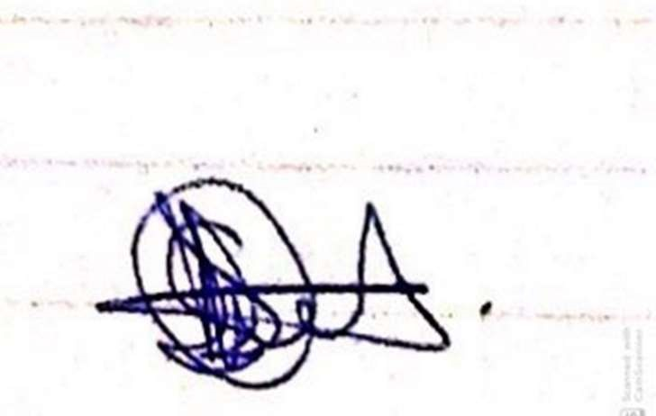

Date: 15/09/19

## Executive Summary

We dwell in a world where technology’s influence is rising rapidly due to new problems which need to be solved by effectiveness in time, cheap in implementation and the safety assured. Due to the rise of globalisation and travel, it is adequate that we resort to faster means to travel from one place to another. Due to the ‘need for speed’ it seems the best solution to fast travel is air. The aeroplane is a good implementation of the idea, but due to its expensiveness and huge size it is not always the solution, this is where the helicopter comes in. But to reassure the passengers to use this transport means safety needs to be addressed and although only skilled interlects get the previledge of flying one, there is need of a help in the flying of this device to reassure this safety. This then calls to Control Engineering as the problem solver. To avoid major crashed due to misjudgement of the pilot and weather disturbances, control systems greatly helps out the aircraft maintain stability in the air at constant height. The following report will describe how this ‘controller’ is made.

Contents

## Table of Contents

DECLARATION ........................................................................................................................ II

EXECUTIVE SUMMARY ................................................................................................................ III

CONTENTS .................................................................................................................................. III

1. INTRODUCTION AND BACKGROUND ON HELICOPTER CONTROL 1

2. TECHNICAL SPECIFICATIONS 1

3. MODELING, SYSTEM IDENTIFICATION AND PROBLEM FORMULATION 2

4. CONTROLLER DESIGN AND SIMULATION 4

5. CONTROLLER IMPLEMENTATION 6

6. SYSTEM TESTING 8

7. CONCLUSIONS 8

8. REFERENCES 9

APPENDIX A 10

APPENDIX B 10

APPENDIX C 11

APPENDIX D 12

APPENDIX E 13

# Introduction and Background on Helicopter Control

[2]

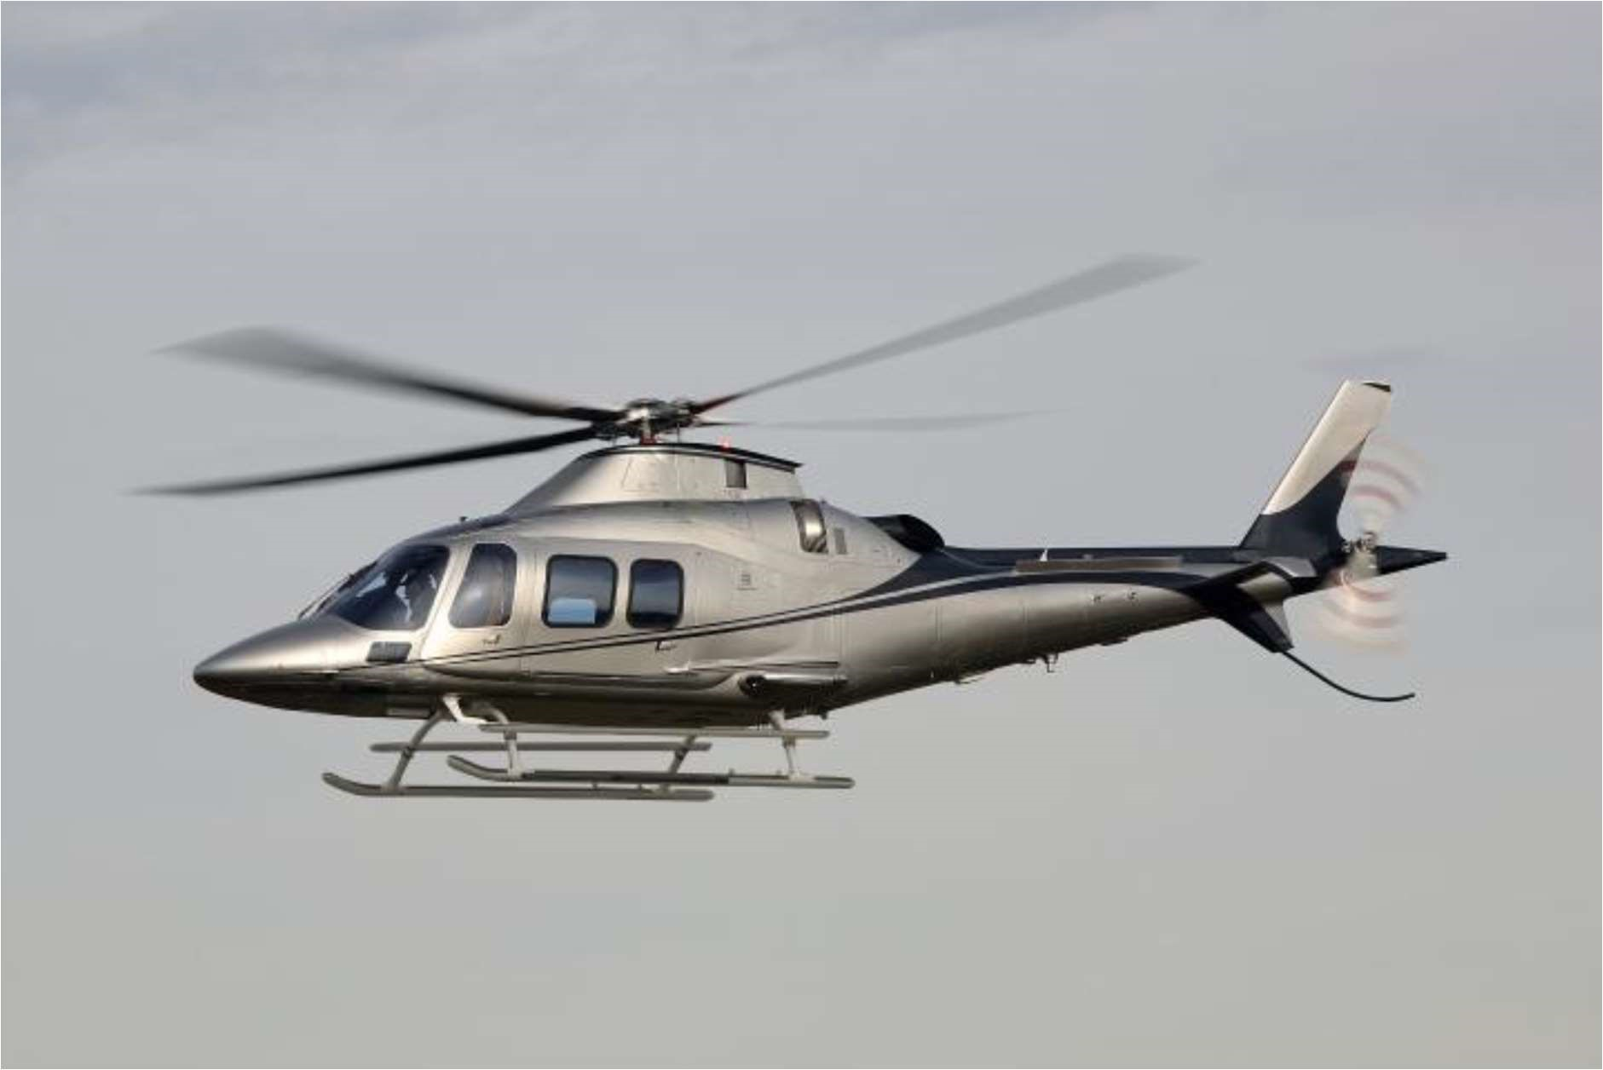

The main difference between aeroplanes and helicopters are the spinning blades that causes lift of the aircraft. They have main and rear rotors which allow them to rise without the need of a runway.They start rotating and require a certain angle of attack to start lifting up.

The system requires a voltage as input(offset) which will determine the angle of attack. The angle of attack will determine whether the helicopter hovers,lifts or lowers down. The output of the system is the helicopter’s height and velocity.

Although as mentioned previously, only skilled people get to pilot a helicopter there is still the need for the helicopter to follow the setpoint that the pilot has desired it to be and without a contoroller this is impossible. It will require constant concentration and readability of future events to maintain stability. The disturbance that are come from the outside like wind, rain and weight need also to be rejected and controlled.

The designing of these controllers make them expensive because of how complicated the system is, it also requires expertise that have a lot of experience to minimise errors in design as it is a disaster-prone infrastructure.

# Technical Specifications

* The steady state error from the setpoint should be 5% deviated at worst
* The steady state disturbance and noise response should be 5% deviated at worst as well.
* There should be less than 20% overshoot or undershoot in transient tracking and disturbance responses
* Assumption that there are input and output disturbances that will occur
* The response of the closed loop system should have a steady state time half of that of the plant

# Modeling, System Identification and Problem Formulation

Modelling

The goal of the project is to control the height of the helicopter. Using an open loop configuration, the angle of attack is set to hover at the median voltage (2.5V) using a potentiometer a step input is implemented. Using the data recorded and from the helicopter app visuals, it can be seen that the height will increase to infinity as time progresses. This is evident that the plant is unstable in relation to height, but another quantity, velocity reaches a steady state. Since velocity is a differential of displacement/height we can divide by time intervals, the height endured by the helicopter(gradient) and retrieve the velocity data. This then shows that the helicopter will increase its height and will achieve a steady increase. Since the velocity is the stable output we could get, we then model it as the output and the input being the step voltage. The plant model is calculated from the data which will be reffered as the mathematical representation of the helicopter (transfer function) .

System identification

The system is estimated to be a first order system due to the graphical appearance of the velocity vs time graph.

A sample of the steady state data:

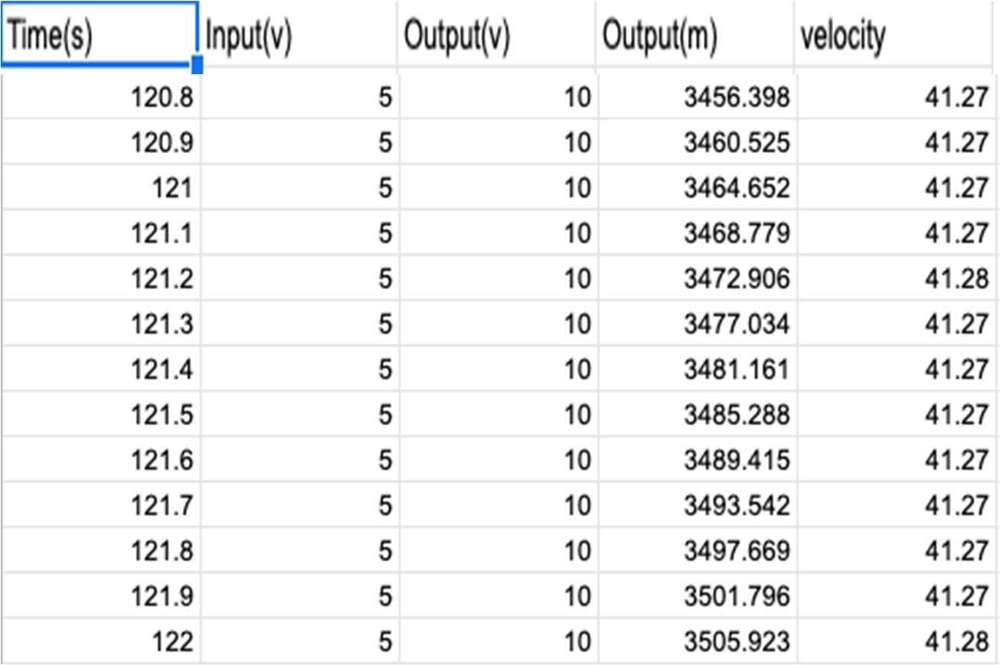

Table 1 : Sample data

Plotting the height vs time graph outputs the following graph:

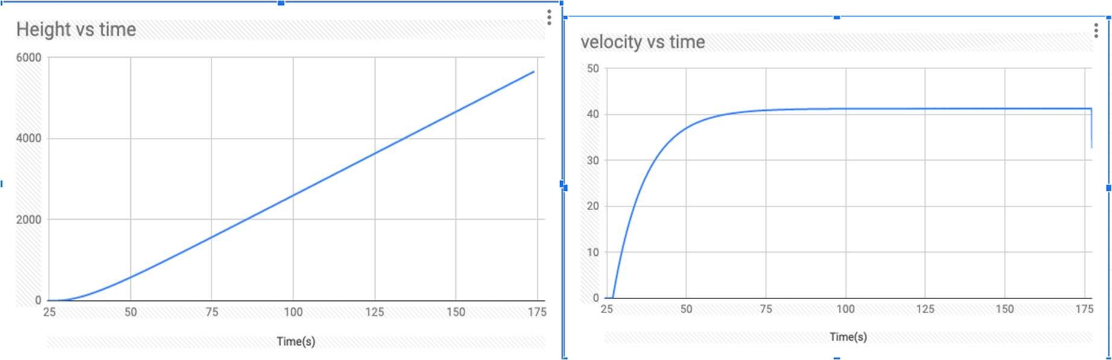

Figure 1 : Output height Figure 2 : Output velocity

The first order linear transfer function is characterized by the following equation

𝐴

𝑔(𝑠) =

### 𝜏𝑠 + 1

Where A = gain  = time constant

The gain is the ration between the initial value subtracted from the final value of the output and input

Time constant is the time taken for the output to be equal to 63.212% of the final value Appendix A shows the other experiments run to confirm the characteristic graph. Determination of A and 

𝐴𝐵 = ()

AB = 41.275

From the graph,

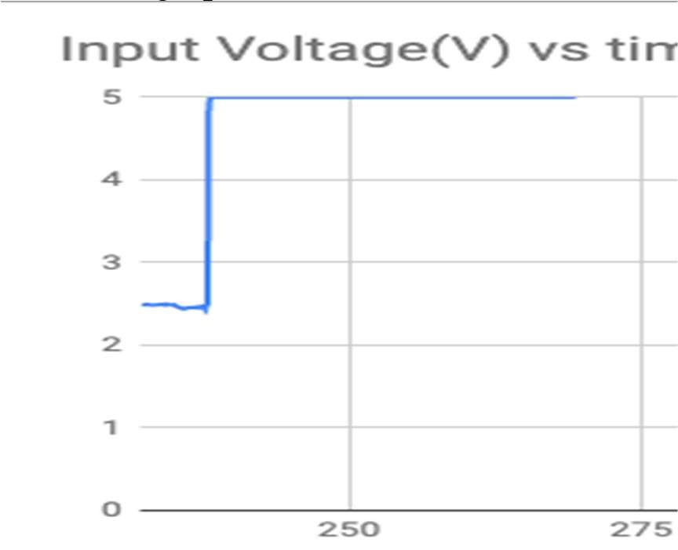

Figure 3 : Step input voltage

B = 5V – 2.5V = 2.5V

A = 16.51

To get  we subtract the time at 63.212% of the final value and the time when the step input happened.After careful calculations and using linearising tools in excel, an accurate  was found to be:

### 𝜏 = 10.19711436

The final model will be adjusted since what we are really interested in is the height not the velocity

And since 𝑠 = ∫ 𝑣𝑑𝑡, an intergrator will be cascaded with the velocity transfer function.

Using the block diagram manipulation in the s-domain gives,

#### 𝐴

𝑔(𝑠) = 𝑠(𝜏𝑠 + 1)

𝑔(𝑠) = 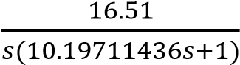

This then reveals why the system is not stable for height, the integrator adds a pole at zero, which is marginally stable.

The sensor converts the height(m) to the voltage that can be fedback

𝑂𝑢𝑡𝑝𝑢𝑡(𝑚) ℎ(𝑠) =

#### 𝑂𝑢𝑡𝑝𝑢𝑡(𝑣)

Using the data before steady state:

ℎ

(

𝑠

)

= 0.95

Open loop config:

Figure 4 : Open loop configuration

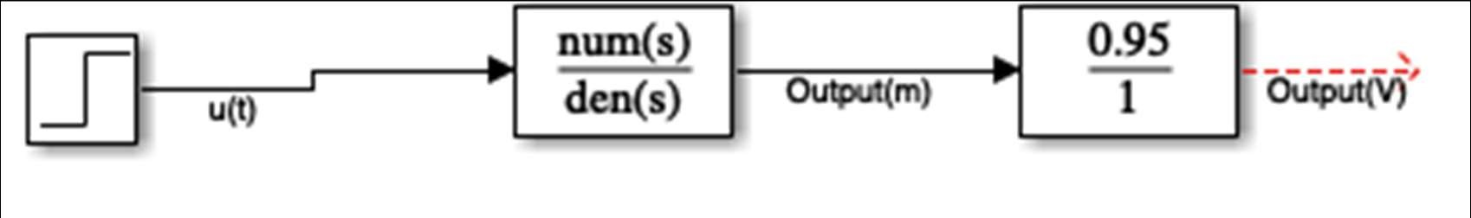

# Controller Design and Simulation

With the given specifications, OS  20% e  5%   5s

The closed loop system should have a certain damping ratio that minimizes the overshoot, should be at least type one to ensure e  0 and settling time  5s

### %𝑂𝑆 = 𝑒 × 100%

[8]

( % )

𝜁 =

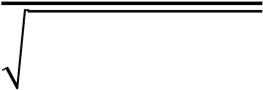 (% )

𝜁 = 0.4559

𝛼 = cos 𝜁

### 𝛼 = 62.9°

The region on the s-plane where the closed loop should be located is therefore:

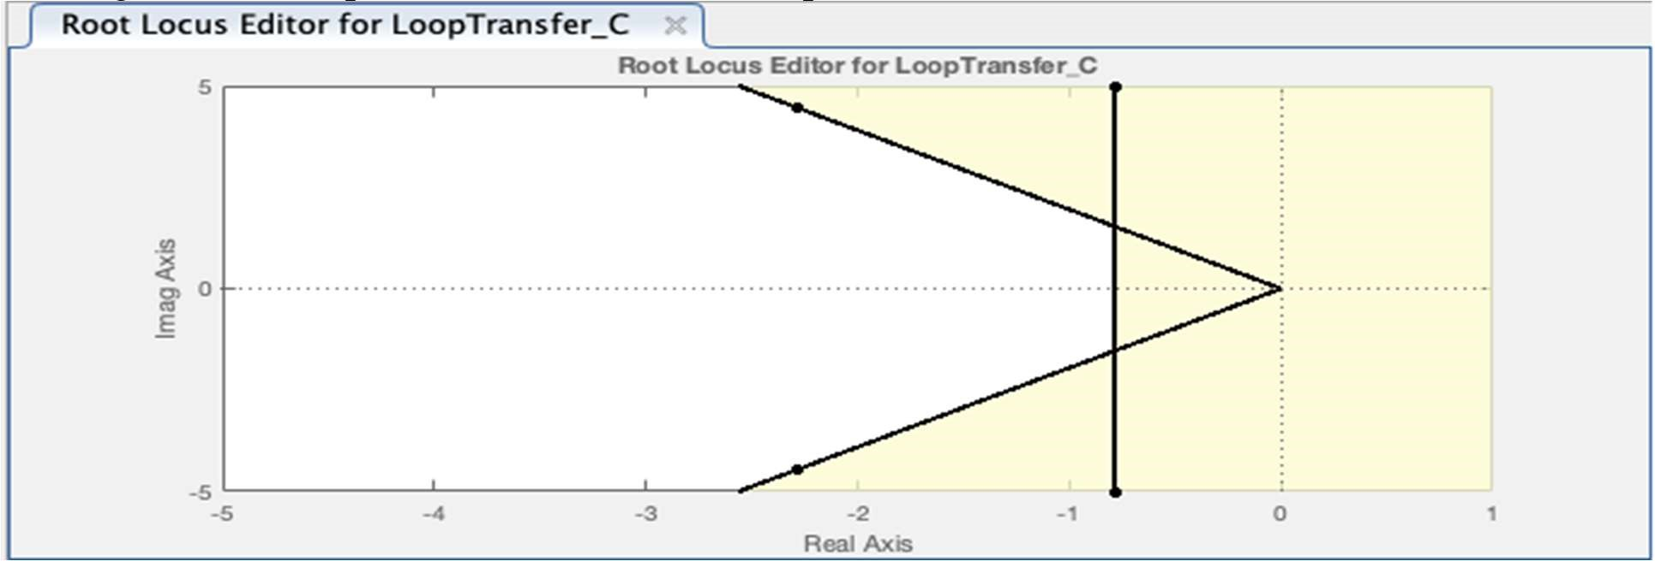

Figure 5 : Root locus specification region for cl-poles

For us to add a controller, the output needs to be monitored and compared to the reference voltage and the controller can make the adjustments to the input u(s). For this to be possible we will have to make a closed loop system where the output will be fed back.

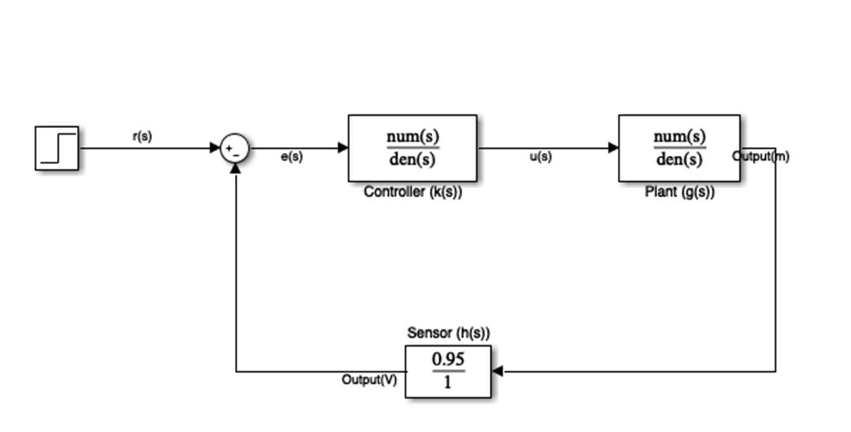

Figure 6 : Closed Loop System Possible controller types :

a) Proportional Controller k(s) = k

𝑘𝑔(𝑠)

∴ 𝑔𝑐𝑙 =

1 + 𝑘𝑔ℎ(𝑠)

[3]

𝐴𝑘

𝑔𝑐𝑙 =

𝜏𝑠 + 𝑠 + 𝐴𝑘ℎ(𝑠)

16.51𝑘

𝑔𝑐𝑙 =

#### 10.2𝑠 + 𝑠 + 15.6845𝑘

Let k(s) = 0.95

In this case the response(Figure 7) is still oscillatory, 88% overshoot, settling time is 79s. Therefore the proportional controller will not meet the requirements.

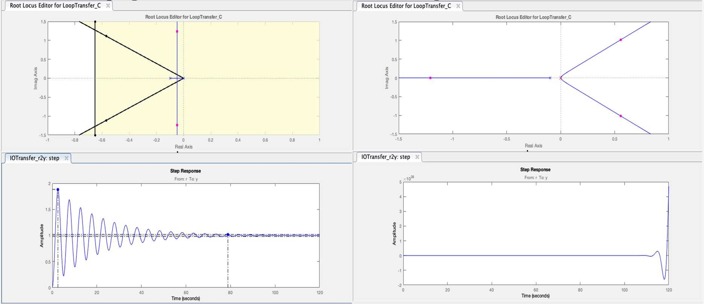

Figure 7 : Proportional controller response Figure 8 : Intergrator controller response

b) Proportional Intergrator(PI)

𝑘 𝑠 𝑔𝑐𝑙 =

𝑘

(

𝑠

)

=

𝐴𝑘

#### 𝜏𝑠 + 𝑠 + 𝐴𝑘ℎ(𝑠)

This controller(Figure 8) does not work as we have introduced another pole at zero, increasing the instability of the system.

c) Differentiator

k(s) = ks

𝐴𝑘𝑠

𝑔𝑐𝑙 =

#### 𝜏𝑠 + 𝑠 + 𝐴𝑘𝑠ℎ(𝑠)

This controller although it has a desirable response (Appendix B1) it is not a causal system. It adds a zero which neutralizes the pole at zero, removing the marginal instability of the system.

d) Lag compensator

(𝑠 − 𝑎)

𝑘(𝑠) = 𝑘

#### (𝑠 − 𝑏)

where a  b

Putting the zero further away from the origin than the pole will only increase the instability, as the pole closest pole to the zero is one that is stable.(Figure 9)

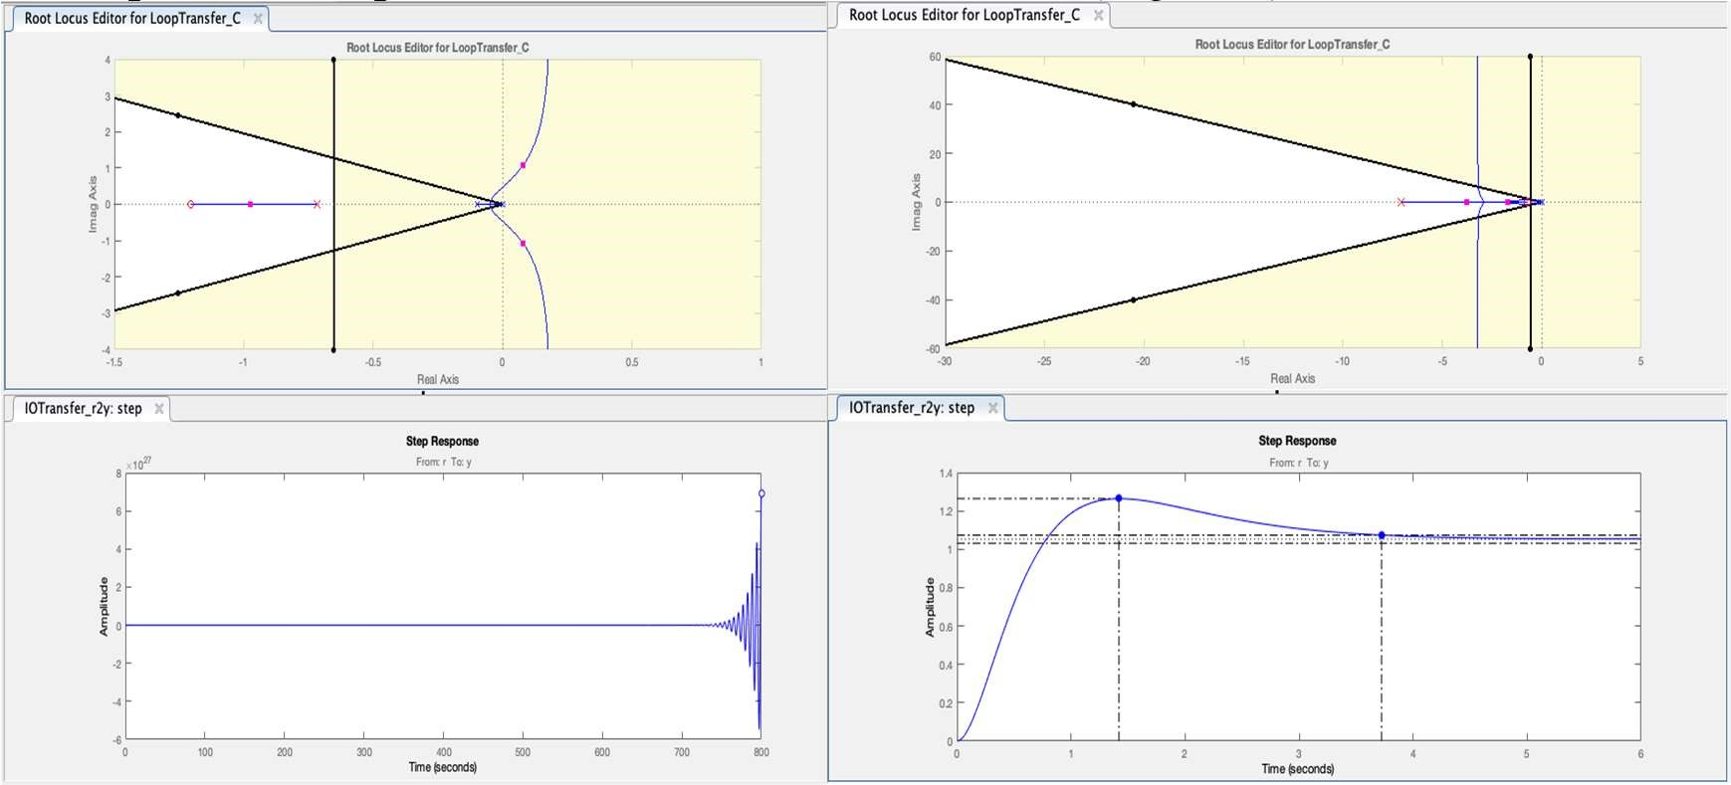

Figure 9 : Lag Compensator Response Figure 10 : Lead compensator Response

e) Lead compensator 𝑘(𝑠) = 𝑘 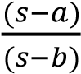 [3]

where a  b

This controller is the most desirable as the response (Figure 10) is causal, the zero is placed near the origin where it will neutralize the pole at the origin, making the system stable and the pole is placed far away such that its not dominating.

# Controller Implementation

1. Proportional controller

k(s) = 0.95

The controller is basically a gain amplifier of gain of 0.95. To achieve this in a circuit, two amplifiers are cascaded one with gain 0.95(Gain = Rf/Rin) the other one with gain of 1 to ensure the voltage polarity is not altered.

The resulting response is that of figure 7, which has oscillatory behavior, very slow and very high overshoot, hence not suitable. Appendix C1 shows the resulting circuit diagram for the proportional controller

1. Lead Compensator 𝑘(𝑠) = 𝑘 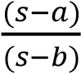 [3]

The lead compensator addd the zero near the open loop poles, s = 0 and s = -0.098, which will reduce their effectiveness and make the system stable. The pole in the compensator will be placed far from the origin to not interfer with the dominance and stability, and also to make the system causal. The pole is placed far enough that the overshoot does not exceed 20%, gain does not exceed 10 and at the same time the system is not too slow. Hence a sweet spot need to be reached.

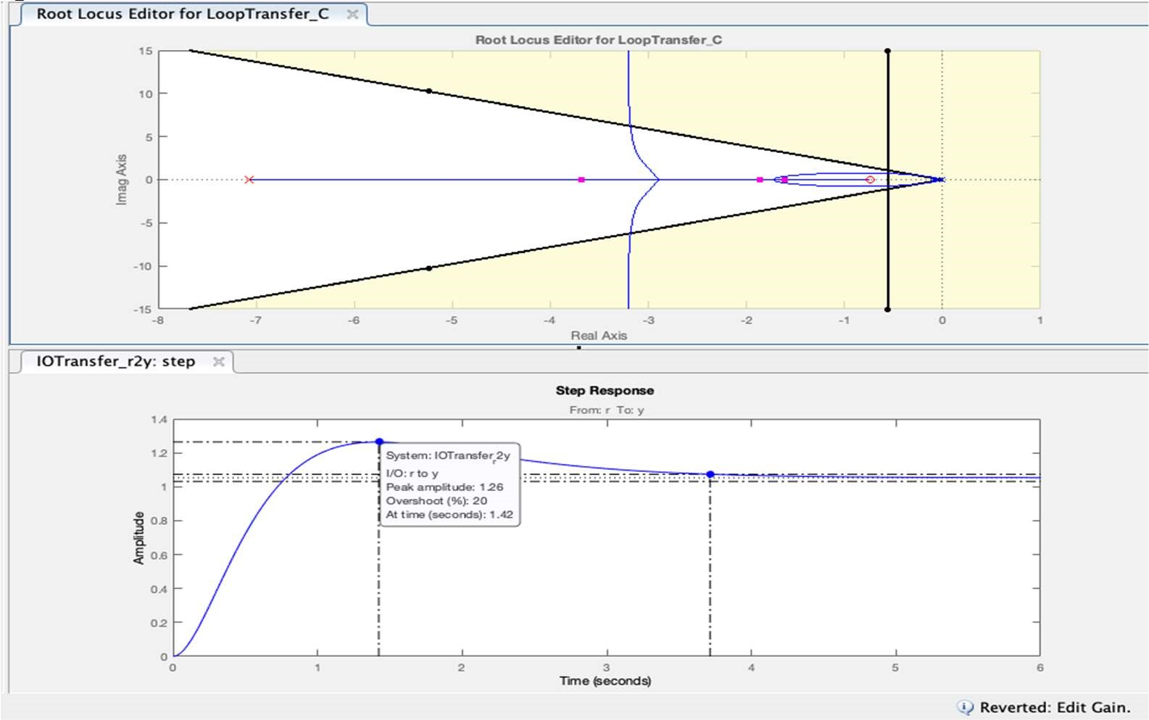

With the assistance of the MATLAB application software to find this ‘sweet spot’ Figure was the eventual considerable response that we adeally need.

### 𝑘(𝑠) = 9.8331

Please refer to Appendix D for the calculations involving the values of the Capacitance and Resistance to the circuit.

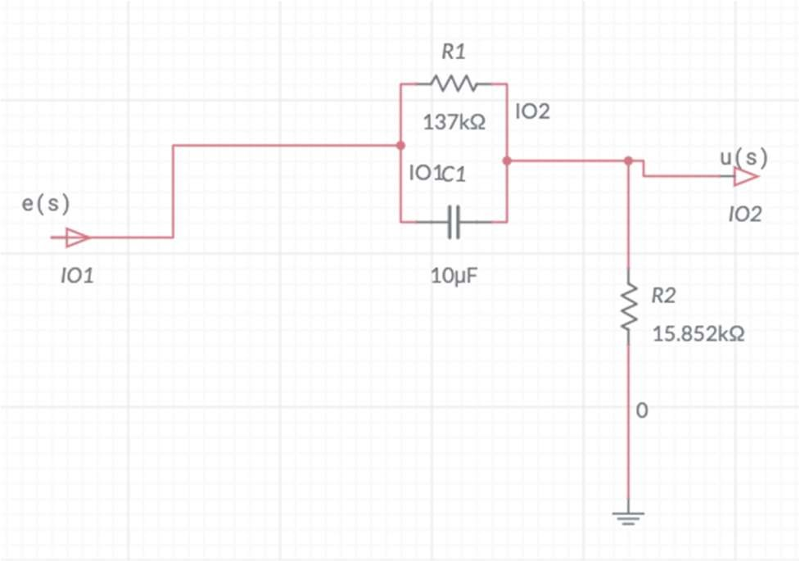 Figure 12 : Lead compensator circuit diagram[

# System Testing

The proportional controller took long to settle at the setpoint voltage and the helicopter was oscillating for more than 20 seconds. The overshoot was way above 50% but the error was minimal. Response was similar to that of the simulation(Figure7) with an increased steady state error.

The helicopter crashed as soon as there was an output disturbance, therefore this is not a considerable

Lead Compensator

The lead compensator had an overshoot of approximately 20% and a steady state period of about 4 seconds, evidenced by Figure 13. At 55s an output disturbance was added and the controller reacted greatly but still had a good time period to achieve steady state again. The tracking was exact, steady state error was 0. This was a good response, one that meets all the specifications. However, the only thing that was very close to the minimum requirement was the overshoot, which was sitting at 19,7%

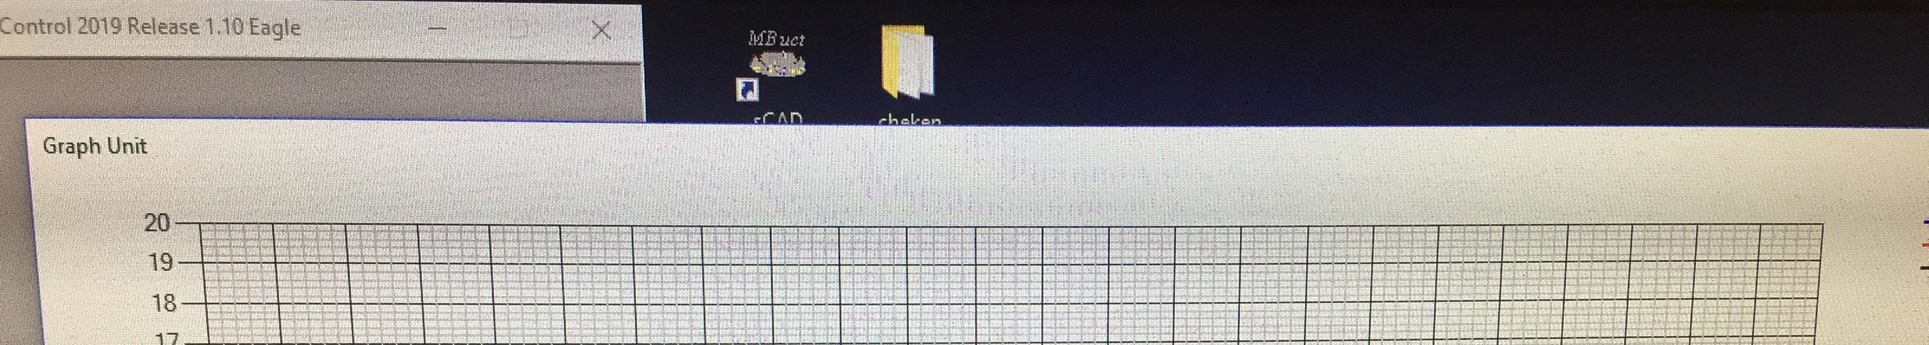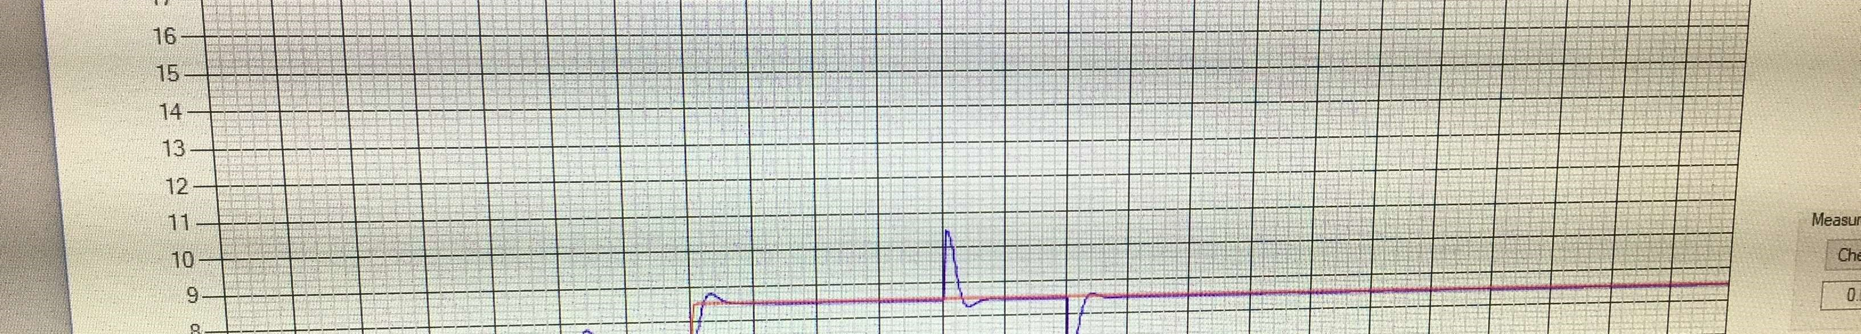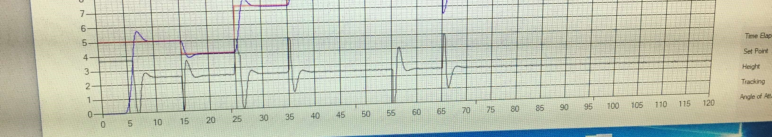

Figure 13: Helicopter testing graphical analysis

Red – setpoint voltage(desired by user)

Blue – tracking voltage(helicopter height)

Black – Offset voltage(Controlled by k(s))

# Conclusions

The lead compensator controller was the chosen as the final controller as it met all the minimum requirements and had characteristics that maximized stability and the speed at the same time minimized overshoot and oscillatory behavior.

The Root Locus Method was used to estimate the pole and zero placement of the controller whilst giving the regions dictated by the system requirements.

The closed loop system was tested via simulation and using the actual electronic implementation. The closed loop system allowed us to control the height of the helicopter and achieve a steady value which was otherwise impossible with the open loop system. The simulation gave a 0% error steady state, which was the same as the circuit implementation. The overshoot was 20% on the simulation and decreased slightly to 19.7% on the circuit implementation

The actual controller for a real life helicopter costs more as the plant model is more complicated and more quality instruments and wiring devices are used. The one for simulation was considerably cheap but because the quality was not that good many errors were encountered during the making of this controller, for me the most frustrating was the faulty wire which had resistance and affected the circuit’s performance greatly during testing.The final circuit design and actual circuit are in Appendix E.

# References

1. https://www.wonderopolis.org/wonder/how-do-helicopters-work
2. http://www.asdnews.com/NewsImages/b/56542/56989_O.jpg
3. Braae M.Braae, Control Engineering – 1,UCT Press (Pty) Ltd. Cape Town, 1996. [4] Tsoeu M.S. Tsoeu, Control and Instrumentation, University of Cape Town, 2018.
4. MATLAB software
5. Multisim.com/create
6. Microsoft Excel software
7. https://ocw.mit.edu/courses/mechanical-engineering/2-004-dynamics-and-control-iispring-2008/lecture-notes/lecture_21.pdf

# Appendix A

<Appendices must be referred to in the main text. Additional modeling and simulation data may be placed here… you may create more appendicies…>

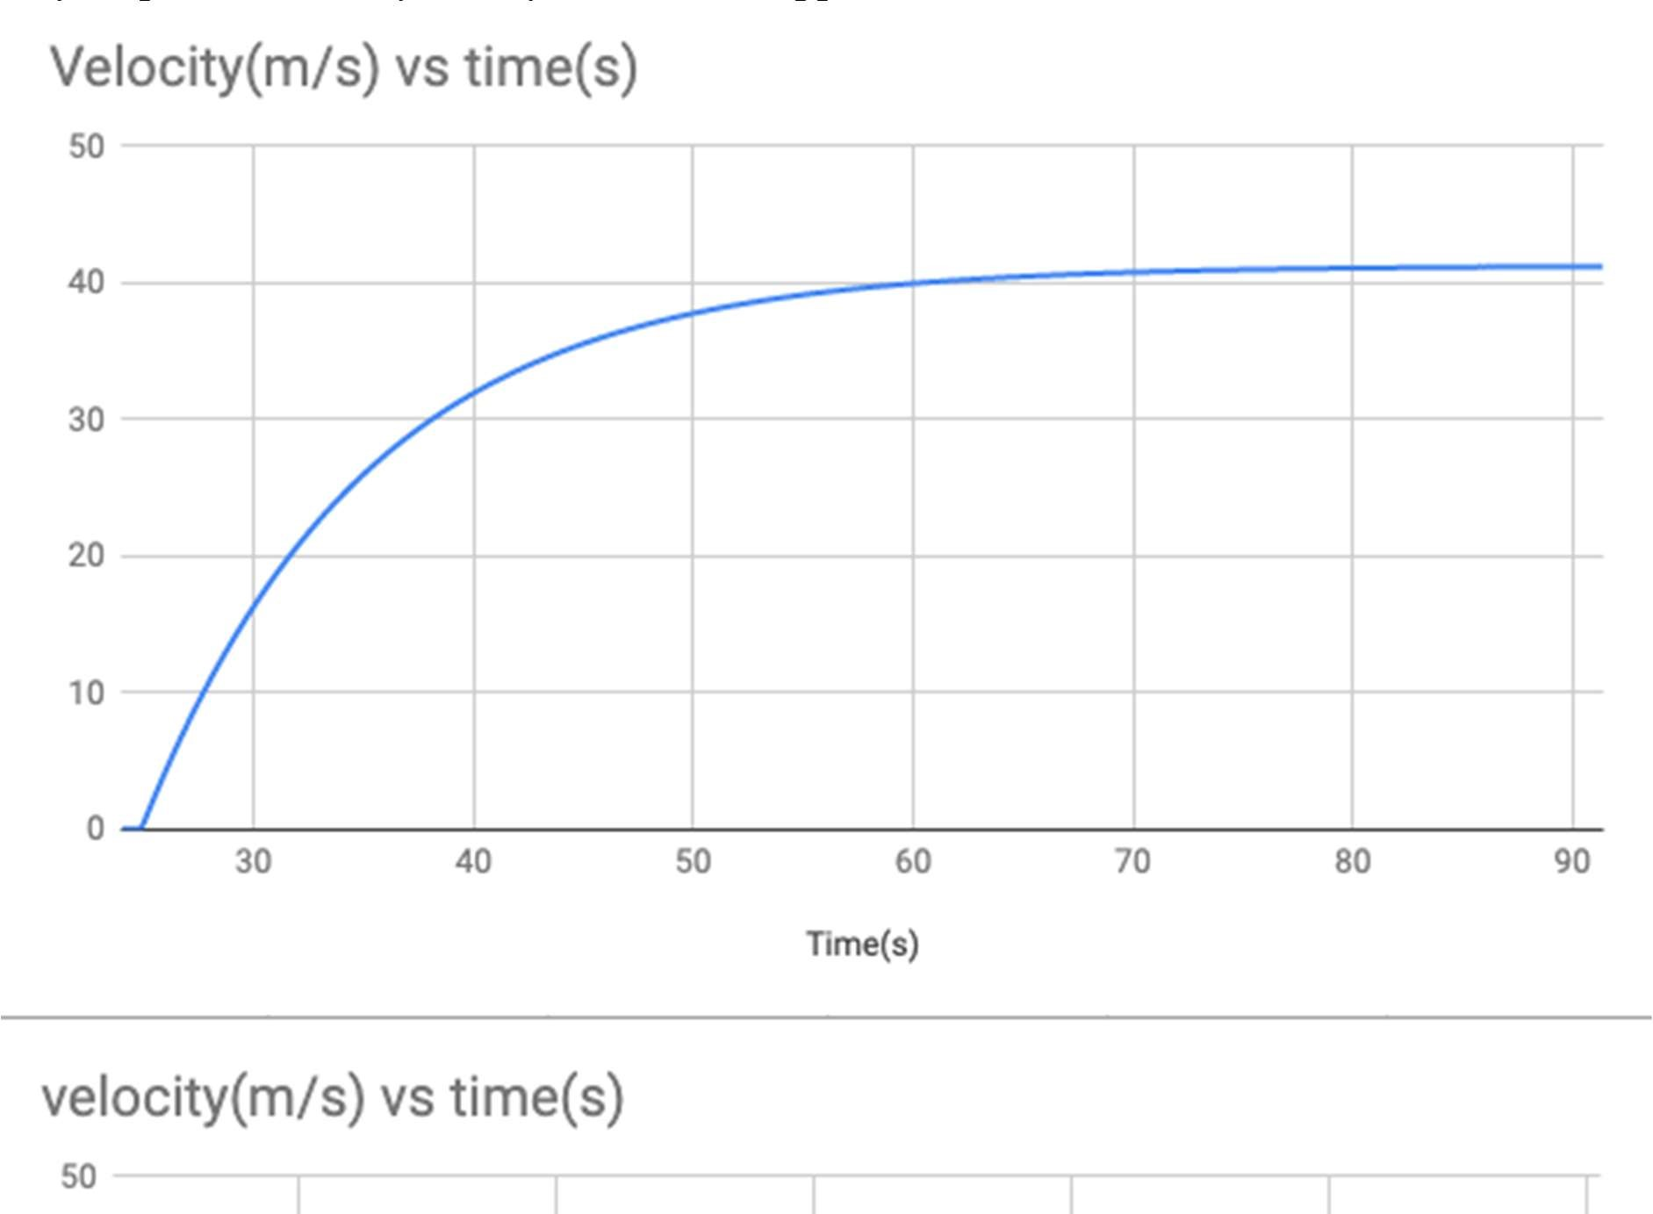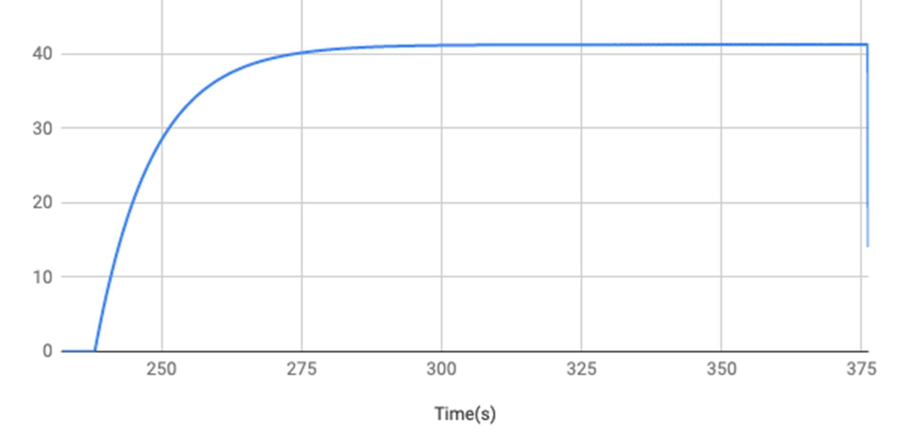

# Appendix B

<More circuit diagrams if needed ….>

Figure : Differential controller Response

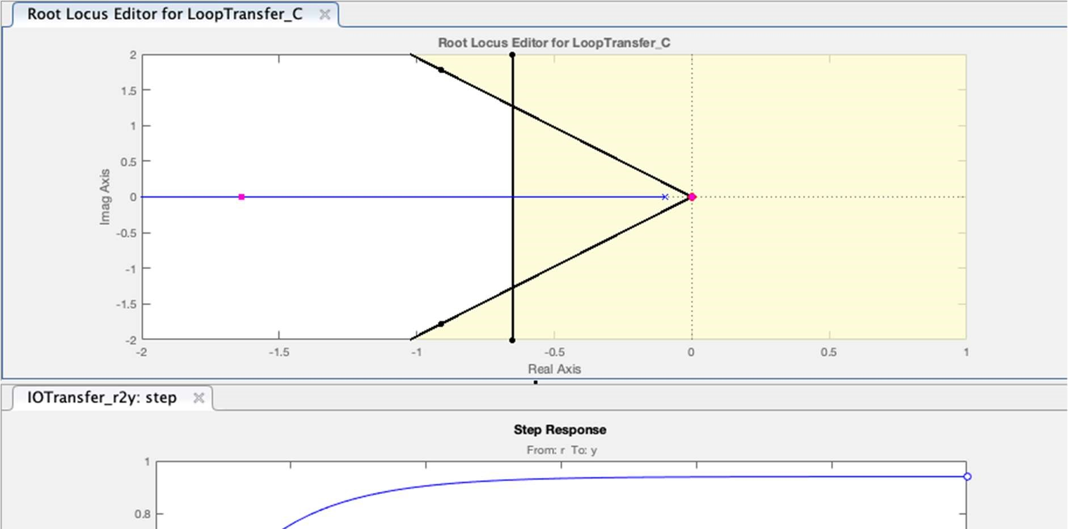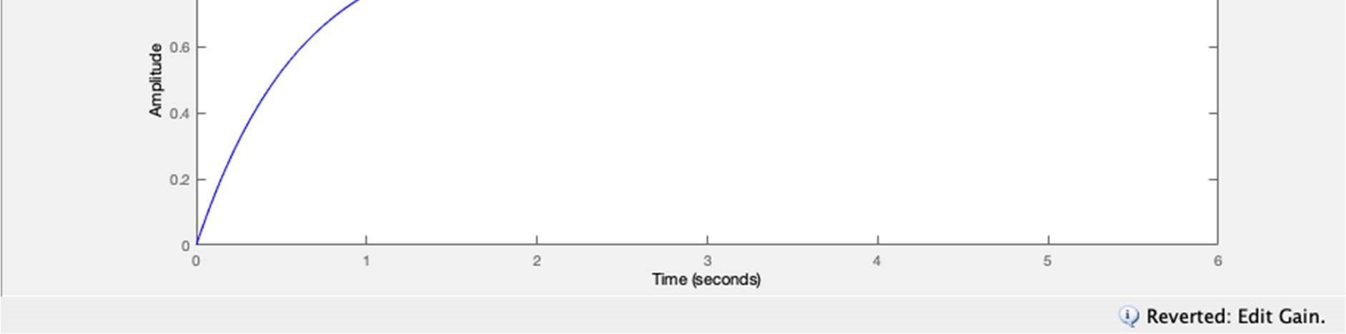

# Appendix C

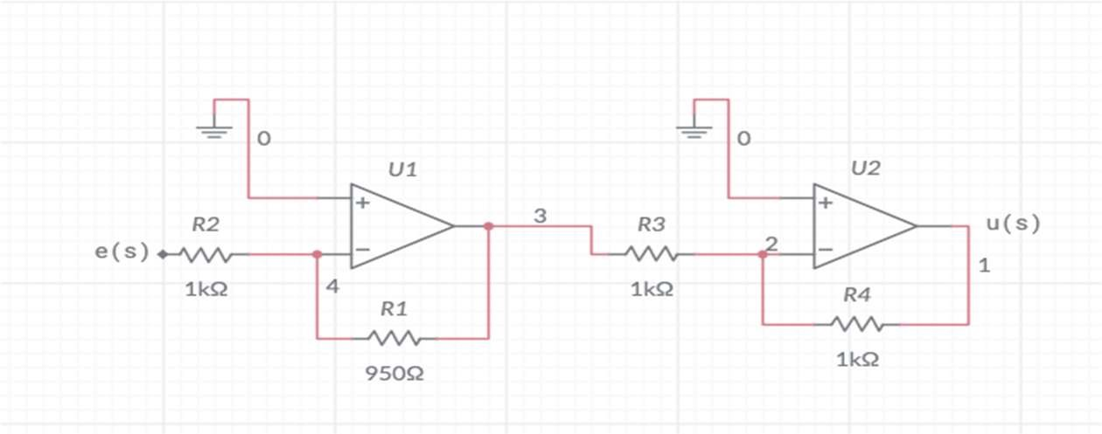

Figure : Proportional controller circuit diagram

# Appendix D

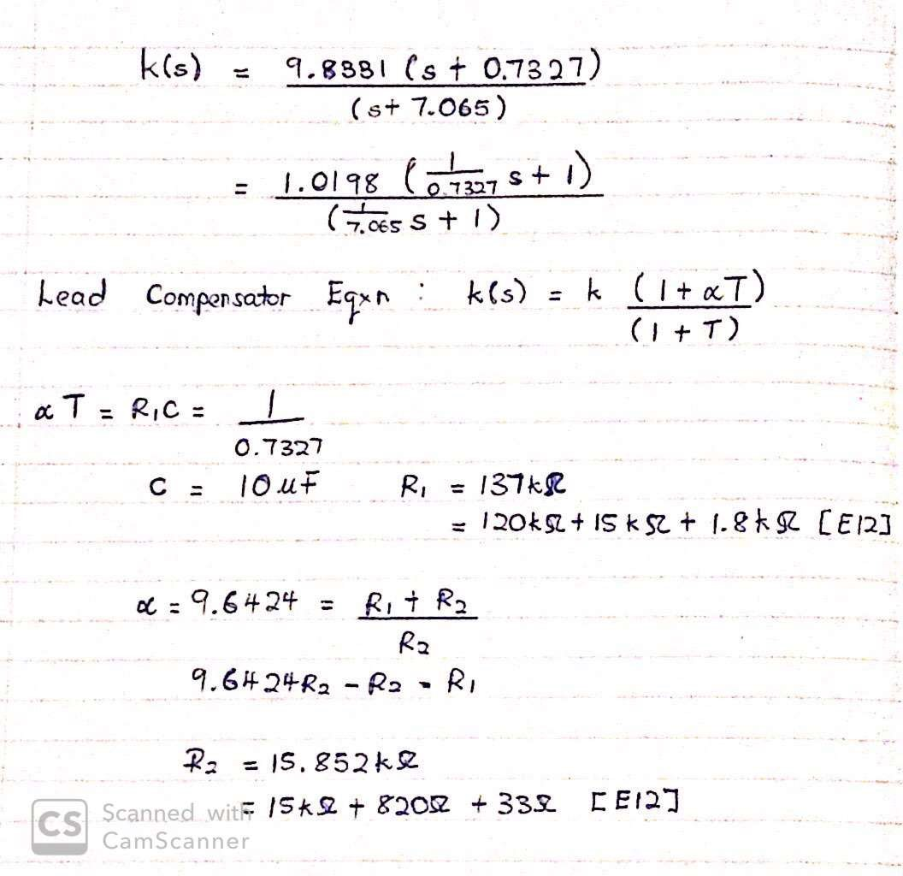

# Appendix E

Figure : Controller Design Circuit

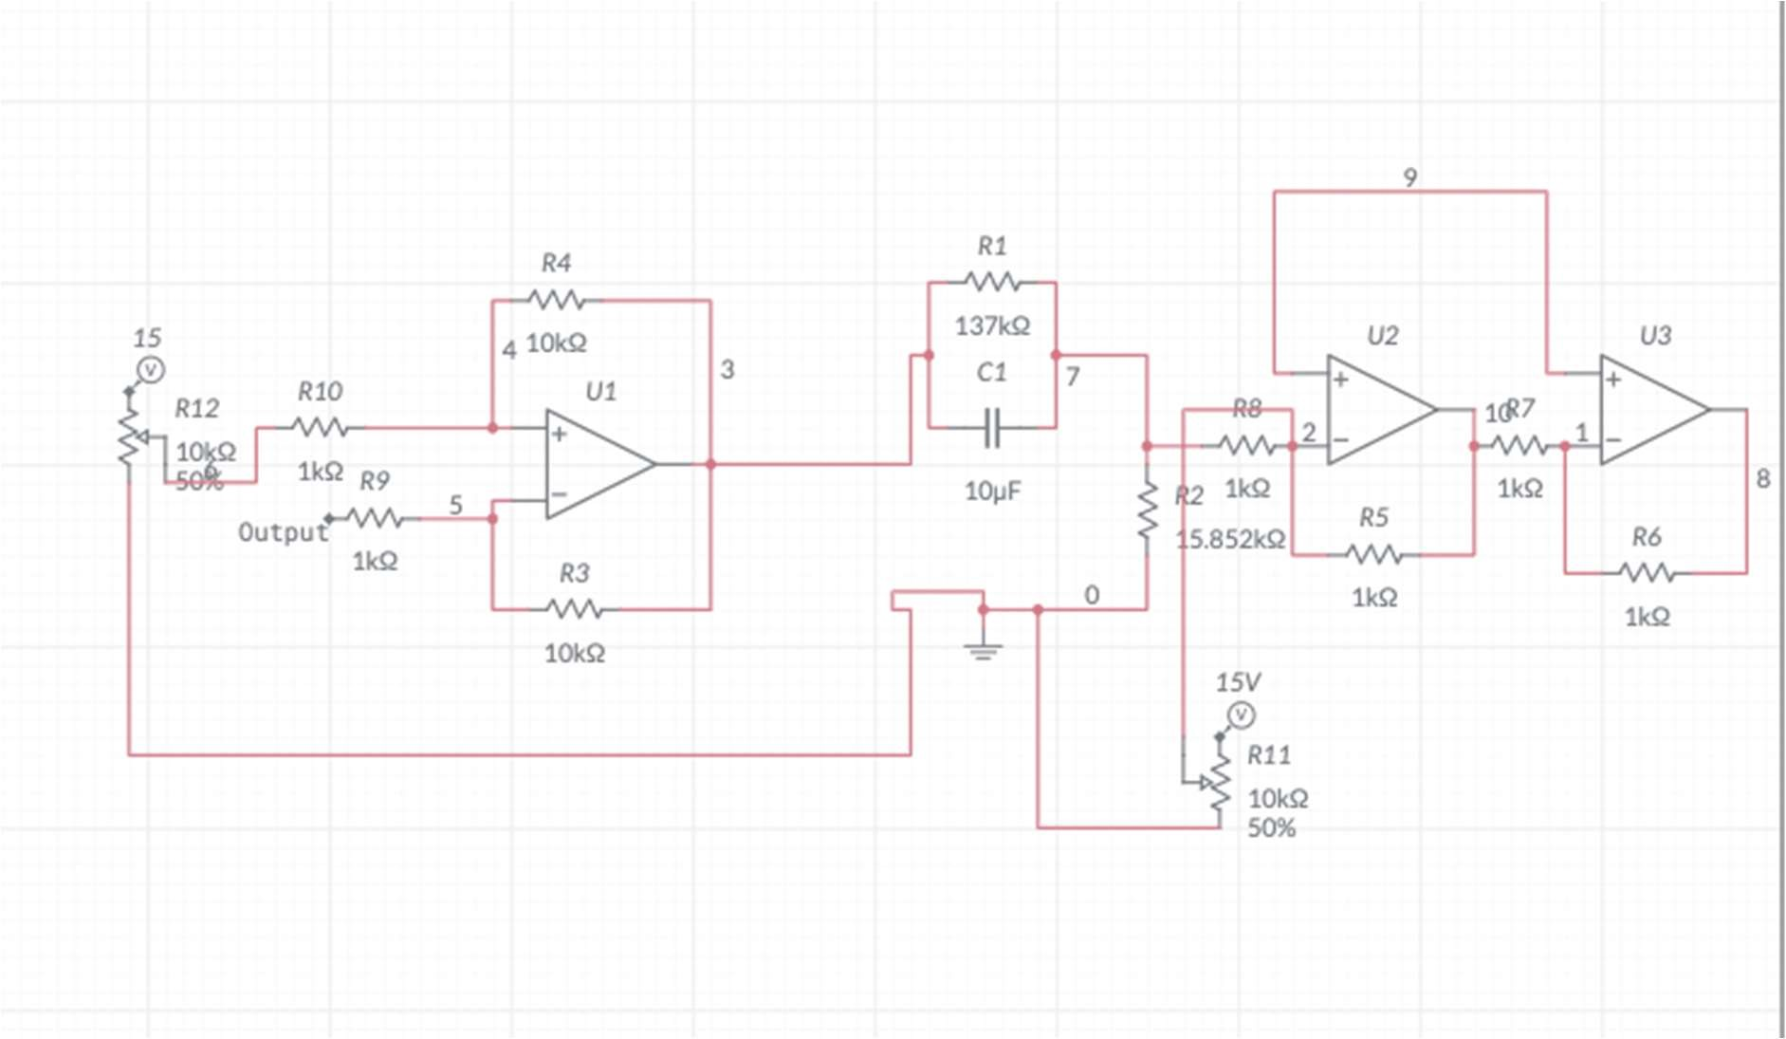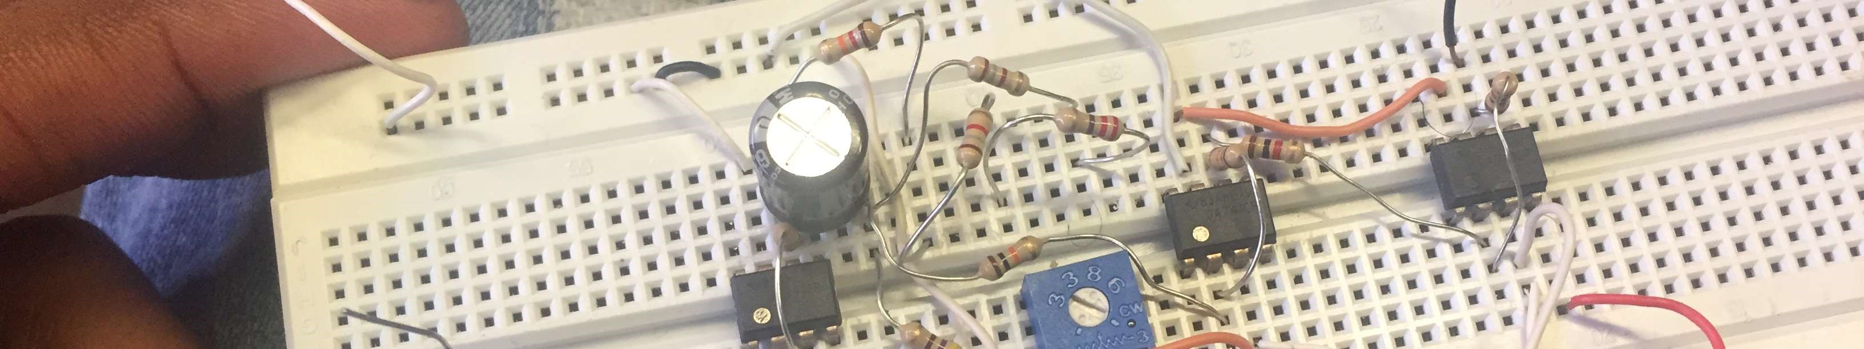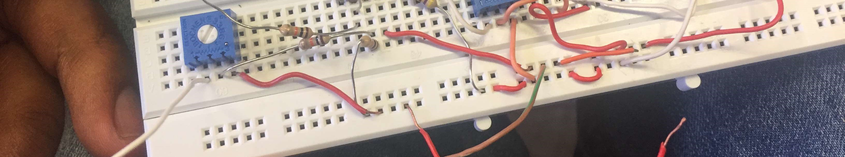

Figure : Controller Design Implementation